# *Database Management I (420-D10-HR)*

# *Lab 03 – Introduction to Oracle*

Date assigned: Monday, August 29, 2016

Date due: **Monday, August 29, 2016, 4:50pm**

**Learning Objectives**

Upon successful completion of this lab exercise, the student will be able to:

* 1. sign on to Oracle using Oracle SQL Developer;
  2. populate a database using an SQL script
  3. Introduction of the Select SQL command to perform simple queries. (We will learn more about SQL and it’s overall structure later, for now we will focus only on the ‘SELECT’ command).

**To uploaded Moodle:**

1. Fill in this document with your answers, rename to ***username_*D10_L03_Oracle.doc** and upload to Moodle.

**Marks:**

|  |  |  |
| --- | --- | --- |
| **Question** | **Mark** | **Out of** |
|  |  |  |
| Part C – Manual browsing 16 questions |  | 16 |
| Part D – SQL queries and results |  | 16 |
| Organization |  | 3 |
| **Total** |  | **35** |

Note: Part A, B, C will be demonstrated by your professor. Optionally, you can find similar demonstration videos on youtube on the [basics of using Oracle SQL Developer](https://www.youtube.com/watch?v=TrrM9HCLJn8).

# Logging onto Oracle

***Objectives***: Learn to log on to Oracle using SQL Developer.

Note: you can install SQL developer locally on your personal machines to connect into the Oracle server. SQL Developer is a thin client providing an interface into the Oracle server where most of the heavy lifting is done.

***To Do:***

## Start **SQL Developer**.

## Select **File 🡪 New 🡪 Database Connection**

## Complete the window as follows:

### **Connection Name**: Anything you want - e.g. your username

### **Username**: Your short username (i.e. rchan)

### **Password**: same as your username

### **Role**: default

### **Connection Type**: basic

### **Hostname**: csoracle.cegep-heritage.qc.ca

### **Port**: 1521

### **SID**: xe

## Click **Connect**. A window will open with your connection name in the tab.

# Run an SQL Script

***Objectives***: Run an SQL script to create a sample database.

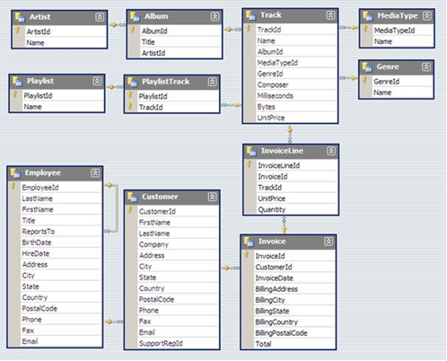

***Chinook database,. Step by step commands on how to run this will be demonstrated for you.***

# Browsing and Navigating within SQL Developer

***Objectives***: Learn how to browse a database using SQL Developer.

Note that there is a Connections window shows you all your sessions with the Oracle servers.

You can browse the database using this window.

Class follow-along exercise.

Look for your session on the left. (You can have several sessions open simultaneously to different databases. For now, you just have one).

Expand the “Tables”

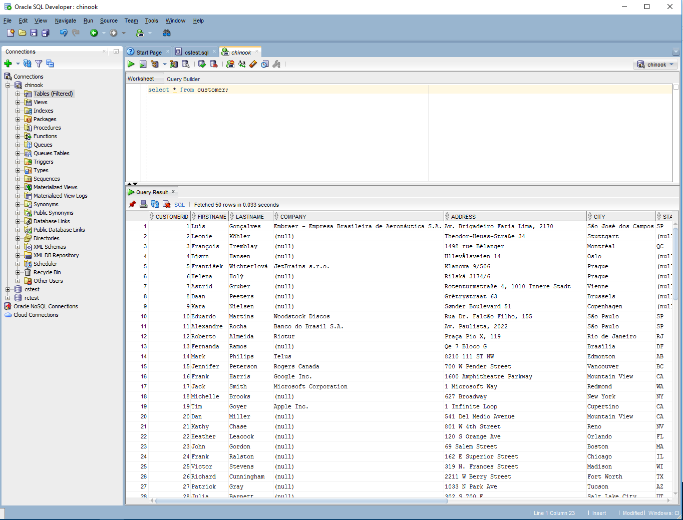

Note that the Tables contained in the database are now shown.

You can select a table to see details on a table.

Click on the Customer table to see details on the CUSTOMER table.

Note that a new tab opens up on the right window frame showing you details of the CUSTOMER table.

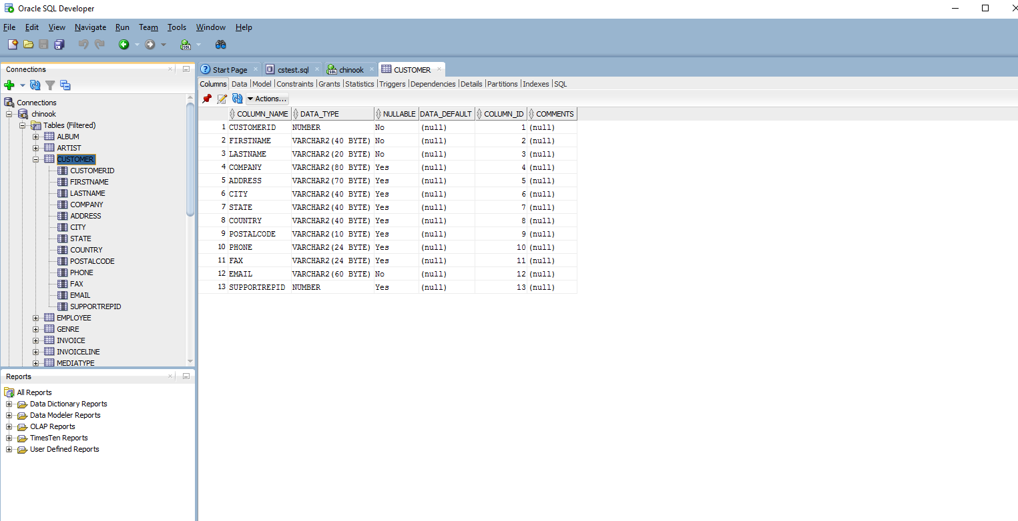

Note also that there are multiple sub-tabs within the new CUSTOMER frame.

For now experiment with the “Columns” and the “Data” sub-tabs to see what the columns of the Customer table are, and what the raw data contained is.

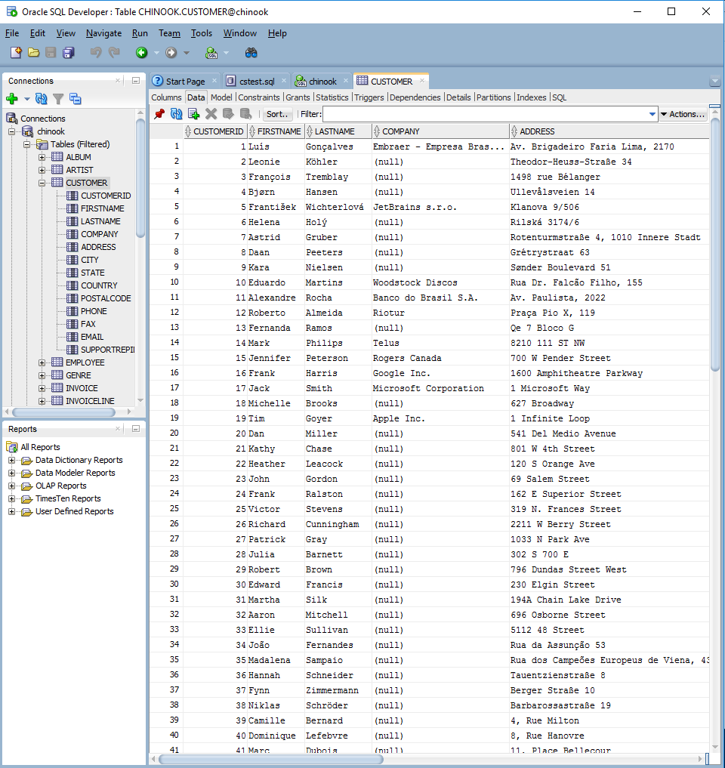

Note that the column headers of the data allow you to sort and filter. (Hint: This will come in handy later in this lab).

Browse the database and complete the following table:

|  |  |
| --- | --- |
| Question | Answer |
| What tables are part of the Chinook database? | * ALBUM * ARTIST * CUSTOMER * EMPLOYEE * GENRE * INVOICE * INVOICELINE * MEDIATYPE * PLAYLIST * PLAYLISTTRACK * TRACK |
| What fields are in the Employee table? | EMPLOYEEID  LASTNAME  FIRSTNAME  TITLE  REPORTSTO  BIRTHDATE  HIREDATE  ADDRESS  CITY  STATE  COUNTRY  POSTALCODE  PHONE  FAX  EMAIL |
| What datatype of field is the Employee phone number? What is the maximum length (in characters) of the Employee phone number? | Datatype: VARCHAR2  Length: 24 characters |
| How many Employee records are there in the database? | 8 |
| What is the name of EmployeeId 5? | Steve Johnson |
| Who is the manager of Laura Callahan | Michael Mitchell |
| Who reports to Nancy Edwards | Jane Peacock  Margaret Park  Steve Johnson |
| The company sells meda (video/audio) online. How many Genre categories are there? | 25 |
| Pick your favourite genre. What is it and what is the corresponding GenreId? | Genreid: 1  Name: Rock |
| How many different Artists are in the database? | 275 |
| Who is the artist with artistID = 167 | Big & Rich |
| What is the name of the Artist for the album American Idiot. Explain how you figured this out using the table names, fields and values. | Green Day.  Filter the album table to the title American Idiot, then find the artist ID. Then find the artist with the corresponding Id in the artist table. |
| What is the name of the 11th track on the album American Idiot? Explain how you figured this out using the table names, fields and values. | Letterbomb  Filter the album table to American Idiot. Find the album Id. Go to the Track table and filter the album it to that of Green day. Find the 11th track. |
| What albums by Queen are in the database? Explain how you figured this out using the table names, fields and values. (Do this for the rest of the questions) | Greatest Hits II  Greatest Hits I  News Of The World  Find the artist ID for Queen. Filter the album table to albums with that album ID. |
| What is the 17th track of Queen’s “Greatest Hits I” | We Are The Champions  Filter the album table to the “Greatest Hits I” album. Find the album’s ID. Filter the track table to that album ID and find the 17th track. |
| What album is the song called “Cucamonga” from? Who are the artist on that album? | Frank Zappa & Captain Beefheart  Filter the track table to “Cucamonga”. Find it’s album ID. Go to the album table and filter by that ID. Find the artist ID associated with that album. Find the artist with that artist ID. |

# Queries I

***Objectives***: Learn the Select command to answer simple queries.

Research: W3Schools [Select](http://www.w3schools.com/sql/sql_select.asp) page. Learn Select, Where, Distinct, Like, order by

All queries start with the CUSTOMER table. Provide the SQL query and the output.

Let’s make sure that you’ve setup everything properly for future logins.

Exit from Oracle SQL Developer.

Restart Oracle SQL Developer, login as yourself and ensure that you can still browse the tables in the database.

**Teacher will demonstrate how to run SQL commands in lab session.**

Reference: <http://www.oracle.com/technetwork/developer-tools/sql-developer/query-intro-1-161240.html#intro> shows the basics on how to run SQL statements in Oracle SQL Developer.

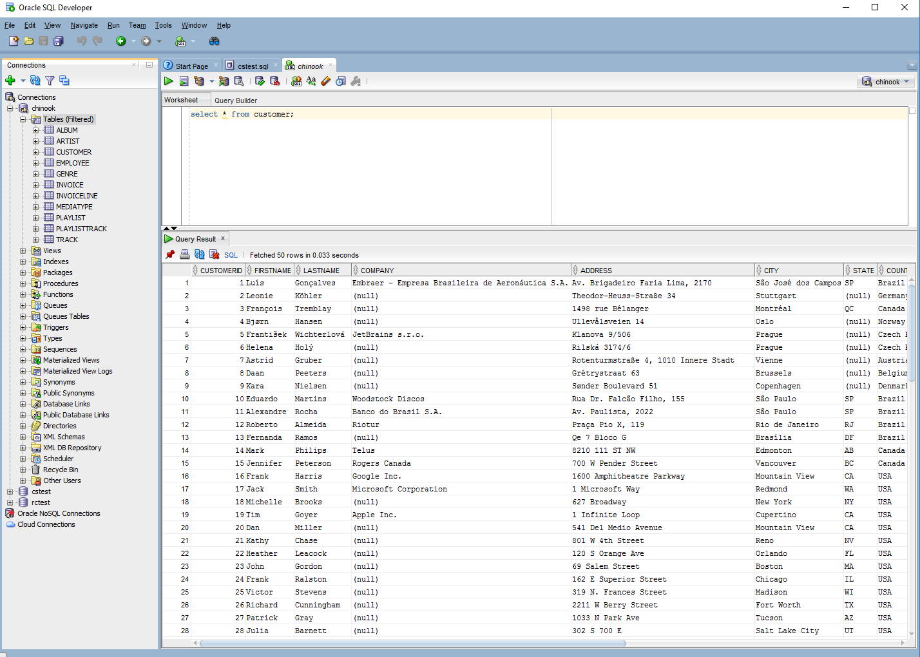

Perform the following queries:

|  |  |  |
| --- | --- | --- |
| Question | SQL Answer | Paste SQL output |
| List all customers | select * from Customer; | 1 Luís Gonçalves Embraer - Empresa Brasileira de Aeronáutica S.A. Av. Brigadeiro Faria Lima, 2170 São José dos Campos SP Brazil 12227-000 +55 (12) 3923-5555 +55 (12) 3923-5566 luisg@embraer.com.br 3  2 Leonie Köhler Theodor-Heuss-Straße 34 Stuttgart Germany 70174 +49 0711 2842222 leonekohler@surfeu.de 5  3 François Tremblay 1498 rue Bélanger Montréal QC Canada H2G 1A7 +1 (514) 721-4711 ftremblay@gmail.com 3  4 Bjørn Hansen Ullevålsveien 14 Oslo Norway 0171 +47 22 44 22 22 bjorn.hansen@yahoo.no 4  5 František Wichterlová JetBrains s.r.o. Klanova 9/506 Prague Czech Republic 14700 +420 2 4172 5555 +420 2 4172 5555 frantisekw@jetbrains.com 4  6 Helena Holý Rilská 3174/6 Prague Czech Republic 14300 +420 2 4177 0449 hholy@gmail.com 5  7 Astrid Gruber Rotenturmstraße 4, 1010 Innere Stadt Vienne Austria 1010 +43 01 5134505 astrid.gruber@apple.at 5  8 Daan Peeters Grétrystraat 63 Brussels Belgium 1000 +32 02 219 03 03 daan_peeters@apple.be 4  9 Kara Nielsen Sønder Boulevard 51 Copenhagen Denmark 1720 +453 3331 9991 kara.nielsen@jubii.dk 4  10 Eduardo Martins Woodstock Discos Rua Dr. Falcão Filho, 155 São Paulo SP Brazil 01007-010 +55 (11) 3033-5446 +55 (11) 3033-4564 eduardo@woodstock.com.br 4  11 Alexandre Rocha Banco do Brasil S.A. Av. Paulista, 2022 São Paulo SP Brazil 01310-200 +55 (11) 3055-3278 +55 (11) 3055-8131 alero@uol.com.br 5  12 Roberto Almeida Riotur Praça Pio X, 119 Rio de Janeiro RJ Brazil 20040-020 +55 (21) 2271-7000 +55 (21) 2271-7070 roberto.almeida@riotur.gov.br 3  13 Fernanda Ramos Qe 7 Bloco G Brasília DF Brazil 71020-677 +55 (61) 3363-5547 +55 (61) 3363-7855 fernadaramos4@uol.com.br 4  14 Mark Philips Telus 8210 111 ST NW Edmonton AB Canada T6G 2C7 +1 (780) 434-4554 +1 (780) 434-5565 mphilips12@shaw.ca 5  15 Jennifer Peterson Rogers Canada 700 W Pender Street Vancouver BC Canada V6C 1G8 +1 (604) 688-2255 +1 (604) 688-8756 jenniferp@rogers.ca 3  16 Frank Harris Google Inc. 1600 Amphitheatre Parkway Mountain View CA USA 94043-1351 +1 (650) 253-0000 +1 (650) 253-0000 fharris@google.com 4  17 Jack Smith Microsoft Corporation 1 Microsoft Way Redmond WA USA 98052-8300 +1 (425) 882-8080 +1 (425) 882-8081 jacksmith@microsoft.com 5  18 Michelle Brooks 627 Broadway New York NY USA 10012-2612 +1 (212) 221-3546 +1 (212) 221-4679 michelleb@aol.com 3  19 Tim Goyer Apple Inc. 1 Infinite Loop Cupertino CA USA 95014 +1 (408) 996-1010 +1 (408) 996-1011 tgoyer@apple.com 3  20 Dan Miller 541 Del Medio Avenue Mountain View CA USA 94040-111 +1 (650) 644-3358 dmiller@comcast.com 4  21 Kathy Chase 801 W 4th Street Reno NV USA 89503 +1 (775) 223-7665 kachase@hotmail.com 5  22 Heather Leacock 120 S Orange Ave Orlando FL USA 32801 +1 (407) 999-7788 hleacock@gmail.com 4  23 John Gordon 69 Salem Street Boston MA USA 2113 +1 (617) 522-1333 johngordon22@yahoo.com 4  24 Frank Ralston 162 E Superior Street Chicago IL USA 60611 +1 (312) 332-3232 fralston@gmail.com 3  25 Victor Stevens 319 N. Frances Street Madison WI USA 53703 +1 (608) 257-0597 vstevens@yahoo.com 5  26 Richard Cunningham 2211 W Berry Street Fort Worth TX USA 76110 +1 (817) 924-7272 ricunningham@hotmail.com 4  27 Patrick Gray 1033 N Park Ave Tucson AZ USA 85719 +1 (520) 622-4200 patrick.gray@aol.com 4  28 Julia Barnett 302 S 700 E Salt Lake City UT USA 84102 +1 (801) 531-7272 jubarnett@gmail.com 5  29 Robert Brown 796 Dundas Street West Toronto ON Canada M6J 1V1 +1 (416) 363-8888 robbrown@shaw.ca 3  30 Edward Francis 230 Elgin Street Ottawa ON Canada K2P 1L7 +1 (613) 234-3322 edfrancis@yachoo.ca 3  31 Martha Silk 194A Chain Lake Drive Halifax NS Canada B3S 1C5 +1 (902) 450-0450 marthasilk@gmail.com 5  32 Aaron Mitchell 696 Osborne Street Winnipeg MB Canada R3L 2B9 +1 (204) 452-6452 aaronmitchell@yahoo.ca 4  33 Ellie Sullivan 5112 48 Street Yellowknife NT Canada X1A 1N6 +1 (867) 920-2233 ellie.sullivan@shaw.ca 3  34 João Fernandes Rua da Assunção 53 Lisbon Portugal +351 (213) 466-111 jfernandes@yahoo.pt 4  35 Madalena Sampaio Rua dos Campeões Europeus de Viena, 4350 Porto Portugal +351 (225) 022-448 masampaio@sapo.pt 4  36 Hannah Schneider Tauentzienstraße 8 Berlin Germany 10789 +49 030 26550280 hannah.schneider@yahoo.de 5  37 Fynn Zimmermann Berger Straße 10 Frankfurt Germany 60316 +49 069 40598889 fzimmermann@yahoo.de 3  38 Niklas Schröder Barbarossastraße 19 Berlin Germany 10779 +49 030 2141444 nschroder@surfeu.de 3  39 Camille Bernard 4, Rue Milton Paris France 75009 +33 01 49 70 65 65 camille.bernard@yahoo.fr 4  40 Dominique Lefebvre 8, Rue Hanovre Paris France 75002 +33 01 47 42 71 71 dominiquelefebvre@gmail.com 4  41 Marc Dubois 11, Place Bellecour Lyon France 69002 +33 04 78 30 30 30 marc.dubois@hotmail.com 5  42 Wyatt Girard 9, Place Louis Barthou Bordeaux France 33000 +33 05 56 96 96 96 wyatt.girard@yahoo.fr 3  43 Isabelle Mercier 68, Rue Jouvence Dijon France 21000 +33 03 80 73 66 99 isabelle_mercier@apple.fr 3  44 Terhi Hämäläinen Porthaninkatu 9 Helsinki Finland 00530 +358 09 870 2000 terhi.hamalainen@apple.fi 3  45 Ladislav Kovács Erzsébet krt. 58. Budapest Hungary H-1073 ladislav_kovacs@apple.hu 3  46 Hugh O'Reilly 3 Chatham Street Dublin Dublin Ireland +353 01 6792424 hughoreilly@apple.ie 3  47 Lucas Mancini Via Degli Scipioni, 43 Rome RM Italy 00192 +39 06 39733434 lucas.mancini@yahoo.it 5  48 Johannes Van der Berg Lijnbaansgracht 120bg Amsterdam VV Netherlands 1016 +31 020 6223130 johavanderberg@yahoo.nl 5  49 Stanislaw Wójcik Ordynacka 10 Warsaw Poland 00-358 +48 22 828 37 39 stanislaw.wójcik@wp.pl 4  50 Enrique Muñoz C/ San Bernardo 85 Madrid Spain 28015 +34 914 454 454 enrique_munoz@yahoo.es 5  51 Joakim Johansson Celsiusg. 9 Stockholm Sweden 11230 +46 08-651 52 52 joakim.johansson@yahoo.se 5  52 Emma Jones 202 Hoxton Street London United Kingdom N1 5LH +44 020 7707 0707 emma_jones@hotmail.com 3  53 Phil Hughes 113 Lupus St London United Kingdom SW1V 3EN +44 020 7976 5722 phil.hughes@gmail.com 3  54 Steve Murray 110 Raeburn Pl Edinburgh United Kingdom EH4 1HH +44 0131 315 3300 steve.murray@yahoo.uk 5  55 Mark Taylor 421 Bourke Street Sidney NSW Australia 2010 +61 (02) 9332 3633 mark.taylor@yahoo.au 4  56 Diego Gutiérrez 307 Macacha Güemes Buenos Aires Argentina 1106 +54 (0)11 4311 4333 diego.gutierrez@yahoo.ar 4  57 Luis Rojas Calle Lira, 198 Santiago Chile +56 (0)2 635 4444 luisrojas@yahoo.cl 5  58 Manoj Pareek 12,Community Centre Delhi India 110017 +91 0124 39883988 manoj.pareek@rediff.com 3  59 Puja Srivastava 3,Raj Bhavan Road Bangalore India 560001 +91 080 22289999 puja_srivastava@yahoo.in 3 |
| List all customers whose address is in CANADA | select * from Customer where COUNTRY='Canada'; | 3 François Tremblay 1498 rue Bélanger Montréal QC Canada H2G 1A7 +1 (514) 721-4711 ftremblay@gmail.com 3  14 Mark Philips Telus 8210 111 ST NW Edmonton AB Canada T6G 2C7 +1 (780) 434-4554 +1 (780) 434-5565 mphilips12@shaw.ca 5  15 Jennifer Peterson Rogers Canada 700 W Pender Street Vancouver BC Canada V6C 1G8 +1 (604) 688-2255 +1 (604) 688-8756 jenniferp@rogers.ca 3  29 Robert Brown 796 Dundas Street West Toronto ON Canada M6J 1V1 +1 (416) 363-8888 robbrown@shaw.ca 3  30 Edward Francis 230 Elgin Street Ottawa ON Canada K2P 1L7 +1 (613) 234-3322 edfrancis@yachoo.ca 3  31 Martha Silk 194A Chain Lake Drive Halifax NS Canada B3S 1C5 +1 (902) 450-0450 marthasilk@gmail.com 5  32 Aaron Mitchell 696 Osborne Street Winnipeg MB Canada R3L 2B9 +1 (204) 452-6452 aaronmitchell@yahoo.ca 4  33 Ellie Sullivan 5112 48 Street Yellowknife NT Canada X1A 1N6 +1 (867) 920-2233 ellie.sullivan@shaw.ca 3 |
| List all customers whose address is in Quebec | select * from Customer where STATE='QC'; | 3 François Tremblay 1498 rue Bélanger Montréal QC Canada H2G 1A7 +1 (514) 721-4711 ftremblay@gmail.com 3 |
| List all customers who is not in USA. | select * from Customer where COUNTRY!='USA'; | 1 Luís Gonçalves Embraer - Empresa Brasileira de Aeronáutica S.A. Av. Brigadeiro Faria Lima, 2170 São José dos Campos SP Brazil 12227-000 +55 (12) 3923-5555 +55 (12) 3923-5566 luisg@embraer.com.br 3  2 Leonie Köhler Theodor-Heuss-Straße 34 Stuttgart Germany 70174 +49 0711 2842222 leonekohler@surfeu.de 5  3 François Tremblay 1498 rue Bélanger Montréal QC Canada H2G 1A7 +1 (514) 721-4711 ftremblay@gmail.com 3  4 Bjørn Hansen Ullevålsveien 14 Oslo Norway 0171 +47 22 44 22 22 bjorn.hansen@yahoo.no 4  5 František Wichterlová JetBrains s.r.o. Klanova 9/506 Prague Czech Republic 14700 +420 2 4172 5555 +420 2 4172 5555 frantisekw@jetbrains.com 4  6 Helena Holý Rilská 3174/6 Prague Czech Republic 14300 +420 2 4177 0449 hholy@gmail.com 5  7 Astrid Gruber Rotenturmstraße 4, 1010 Innere Stadt Vienne Austria 1010 +43 01 5134505 astrid.gruber@apple.at 5  8 Daan Peeters Grétrystraat 63 Brussels Belgium 1000 +32 02 219 03 03 daan_peeters@apple.be 4  9 Kara Nielsen Sønder Boulevard 51 Copenhagen Denmark 1720 +453 3331 9991 kara.nielsen@jubii.dk 4  10 Eduardo Martins Woodstock Discos Rua Dr. Falcão Filho, 155 São Paulo SP Brazil 01007-010 +55 (11) 3033-5446 +55 (11) 3033-4564 eduardo@woodstock.com.br 4  11 Alexandre Rocha Banco do Brasil S.A. Av. Paulista, 2022 São Paulo SP Brazil 01310-200 +55 (11) 3055-3278 +55 (11) 3055-8131 alero@uol.com.br 5  12 Roberto Almeida Riotur Praça Pio X, 119 Rio de Janeiro RJ Brazil 20040-020 +55 (21) 2271-7000 +55 (21) 2271-7070 roberto.almeida@riotur.gov.br 3  13 Fernanda Ramos Qe 7 Bloco G Brasília DF Brazil 71020-677 +55 (61) 3363-5547 +55 (61) 3363-7855 fernadaramos4@uol.com.br 4  14 Mark Philips Telus 8210 111 ST NW Edmonton AB Canada T6G 2C7 +1 (780) 434-4554 +1 (780) 434-5565 mphilips12@shaw.ca 5  15 Jennifer Peterson Rogers Canada 700 W Pender Street Vancouver BC Canada V6C 1G8 +1 (604) 688-2255 +1 (604) 688-8756 jenniferp@rogers.ca 3  29 Robert Brown 796 Dundas Street West Toronto ON Canada M6J 1V1 +1 (416) 363-8888 robbrown@shaw.ca 3  30 Edward Francis 230 Elgin Street Ottawa ON Canada K2P 1L7 +1 (613) 234-3322 edfrancis@yachoo.ca 3  31 Martha Silk 194A Chain Lake Drive Halifax NS Canada B3S 1C5 +1 (902) 450-0450 marthasilk@gmail.com 5  32 Aaron Mitchell 696 Osborne Street Winnipeg MB Canada R3L 2B9 +1 (204) 452-6452 aaronmitchell@yahoo.ca 4  33 Ellie Sullivan 5112 48 Street Yellowknife NT Canada X1A 1N6 +1 (867) 920-2233 ellie.sullivan@shaw.ca 3  34 João Fernandes Rua da Assunção 53 Lisbon Portugal +351 (213) 466-111 jfernandes@yahoo.pt 4  35 Madalena Sampaio Rua dos Campeões Europeus de Viena, 4350 Porto Portugal +351 (225) 022-448 masampaio@sapo.pt 4  36 Hannah Schneider Tauentzienstraße 8 Berlin Germany 10789 +49 030 26550280 hannah.schneider@yahoo.de 5  37 Fynn Zimmermann Berger Straße 10 Frankfurt Germany 60316 +49 069 40598889 fzimmermann@yahoo.de 3  38 Niklas Schröder Barbarossastraße 19 Berlin Germany 10779 +49 030 2141444 nschroder@surfeu.de 3  39 Camille Bernard 4, Rue Milton Paris France 75009 +33 01 49 70 65 65 camille.bernard@yahoo.fr 4  40 Dominique Lefebvre 8, Rue Hanovre Paris France 75002 +33 01 47 42 71 71 dominiquelefebvre@gmail.com 4  41 Marc Dubois 11, Place Bellecour Lyon France 69002 +33 04 78 30 30 30 marc.dubois@hotmail.com 5  42 Wyatt Girard 9, Place Louis Barthou Bordeaux France 33000 +33 05 56 96 96 96 wyatt.girard@yahoo.fr 3  43 Isabelle Mercier 68, Rue Jouvence Dijon France 21000 +33 03 80 73 66 99 isabelle_mercier@apple.fr 3  44 Terhi Hämäläinen Porthaninkatu 9 Helsinki Finland 00530 +358 09 870 2000 terhi.hamalainen@apple.fi 3  45 Ladislav Kovács Erzsébet krt. 58. Budapest Hungary H-1073 ladislav_kovacs@apple.hu 3  46 Hugh O'Reilly 3 Chatham Street Dublin Dublin Ireland +353 01 6792424 hughoreilly@apple.ie 3  47 Lucas Mancini Via Degli Scipioni, 43 Rome RM Italy 00192 +39 06 39733434 lucas.mancini@yahoo.it 5  48 Johannes Van der Berg Lijnbaansgracht 120bg Amsterdam VV Netherlands 1016 +31 020 6223130 johavanderberg@yahoo.nl 5  49 Stanislaw Wójcik Ordynacka 10 Warsaw Poland 00-358 +48 22 828 37 39 stanislaw.wójcik@wp.pl 4  50 Enrique Muñoz C/ San Bernardo 85 Madrid Spain 28015 +34 914 454 454 enrique_munoz@yahoo.es 5  51 Joakim Johansson Celsiusg. 9 Stockholm Sweden 11230 +46 08-651 52 52 joakim.johansson@yahoo.se 5  52 Emma Jones 202 Hoxton Street London United Kingdom N1 5LH +44 020 7707 0707 emma_jones@hotmail.com 3  53 Phil Hughes 113 Lupus St London United Kingdom SW1V 3EN +44 020 7976 5722 phil.hughes@gmail.com 3  54 Steve Murray 110 Raeburn Pl Edinburgh United Kingdom EH4 1HH +44 0131 315 3300 steve.murray@yahoo.uk 5  55 Mark Taylor 421 Bourke Street Sidney NSW Australia 2010 +61 (02) 9332 3633 mark.taylor@yahoo.au 4  56 Diego Gutiérrez 307 Macacha Güemes Buenos Aires Argentina 1106 +54 (0)11 4311 4333 diego.gutierrez@yahoo.ar 4  57 Luis Rojas Calle Lira, 198 Santiago Chile +56 (0)2 635 4444 luisrojas@yahoo.cl 5  58 Manoj Pareek 12,Community Centre Delhi India 110017 +91 0124 39883988 manoj.pareek@rediff.com 3  59 Puja Srivastava 3,Raj Bhavan Road Bangalore India 560001 +91 080 22289999 puja_srivastava@yahoo.in 3 |
| Show only the first and last name, and email of all customers | select firstname, lastname, email from Customer; | Luís Gonçalves luisg@embraer.com.br  Leonie Köhler leonekohler@surfeu.de  François Tremblay ftremblay@gmail.com  Bjørn Hansen bjorn.hansen@yahoo.no  František Wichterlová frantisekw@jetbrains.com  Helena Holý hholy@gmail.com  Astrid Gruber astrid.gruber@apple.at  Daan Peeters daan_peeters@apple.be  Kara Nielsen kara.nielsen@jubii.dk  Eduardo Martins eduardo@woodstock.com.br  Alexandre Rocha alero@uol.com.br  Roberto Almeida roberto.almeida@riotur.gov.br  Fernanda Ramos fernadaramos4@uol.com.br  Mark Philips mphilips12@shaw.ca  Jennifer Peterson jenniferp@rogers.ca  Frank Harris fharris@google.com  Jack Smith jacksmith@microsoft.com  Michelle Brooks michelleb@aol.com  Tim Goyer tgoyer@apple.com  Dan Miller dmiller@comcast.com  Kathy Chase kachase@hotmail.com  Heather Leacock hleacock@gmail.com  John Gordon johngordon22@yahoo.com  Frank Ralston fralston@gmail.com  Victor Stevens vstevens@yahoo.com  Richard Cunningham ricunningham@hotmail.com  Patrick Gray patrick.gray@aol.com  Julia Barnett jubarnett@gmail.com  Robert Brown robbrown@shaw.ca  Edward Francis edfrancis@yachoo.ca  Martha Silk marthasilk@gmail.com  Aaron Mitchell aaronmitchell@yahoo.ca  Ellie Sullivan ellie.sullivan@shaw.ca  João Fernandes jfernandes@yahoo.pt  Madalena Sampaio masampaio@sapo.pt  Hannah Schneider hannah.schneider@yahoo.de  Fynn Zimmermann fzimmermann@yahoo.de  Niklas Schröder nschroder@surfeu.de  Camille Bernard camille.bernard@yahoo.fr  Dominique Lefebvre dominiquelefebvre@gmail.com  Marc Dubois marc.dubois@hotmail.com  Wyatt Girard wyatt.girard@yahoo.fr  Isabelle Mercier isabelle_mercier@apple.fr  Terhi Hämäläinen terhi.hamalainen@apple.fi  Ladislav Kovács ladislav_kovacs@apple.hu  Hugh O'Reilly hughoreilly@apple.ie  Lucas Mancini lucas.mancini@yahoo.it  Johannes Van der Berg johavanderberg@yahoo.nl  Stanislaw Wójcik stanislaw.wójcik@wp.pl  Enrique Muñoz enrique_munoz@yahoo.es  Joakim Johansson joakim.johansson@yahoo.se  Emma Jones emma_jones@hotmail.com  Phil Hughes phil.hughes@gmail.com  Steve Murray steve.murray@yahoo.uk  Mark Taylor mark.taylor@yahoo.au  Diego Gutiérrez diego.gutierrez@yahoo.ar  Luis Rojas luisrojas@yahoo.cl  Manoj Pareek manoj.pareek@rediff.com  Puja Srivastava puja_srivastava@yahoo.in |
| Show all distinct cities that the customers are in. How many unique cities are your customers in? | select distinct city from Customer; | Rio de Janeiro  Cupertino  Salt Lake City  London  Brussels  Halifax  Yellowknife  Porto  Berlin  Sidney  São Paulo  Mountain View  Rome  Delhi  Stuttgart  Copenhagen  New York  Fort Worth  Tucson  Frankfurt  Lyon  Dijon  Dublin  Buenos Aires  Montréal  Prague  Brasília  Redmond  Toronto  Edinburgh  Santiago  Bangalore  Oslo  Edmonton  Orlando  Chicago  Winnipeg  Lisbon  Budapest  Warsaw  Stockholm  São José dos Campos  Vienne  Vancouver  Boston  Madison  Bordeaux  Helsinki  Madrid  Reno  Ottawa  Paris  Amsterdam |
| Show only the first and last name of all customers with a gmail address | select firstname, lastname from customer where email like '%gmail.com'; | François Tremblay  Helena Holý  Heather Leacock  Frank Ralston  Julia Barnett  Martha Silk  Dominique Lefebvre  Phil Hughes |
| List all customers that have provided a Company, sorted by company name | select * from customer where company is not null; | 1 Luís Gonçalves Embraer - Empresa Brasileira de Aeronáutica S.A. Av. Brigadeiro Faria Lima, 2170 São José dos Campos SP Brazil 12227-000 +55 (12) 3923-5555 +55 (12) 3923-5566 luisg@embraer.com.br 3  5 František Wichterlová JetBrains s.r.o. Klanova 9/506 Prague Czech Republic 14700 +420 2 4172 5555 +420 2 4172 5555 frantisekw@jetbrains.com 4  10 Eduardo Martins Woodstock Discos Rua Dr. Falcão Filho, 155 São Paulo SP Brazil 01007-010 +55 (11) 3033-5446 +55 (11) 3033-4564 eduardo@woodstock.com.br 4  11 Alexandre Rocha Banco do Brasil S.A. Av. Paulista, 2022 São Paulo SP Brazil 01310-200 +55 (11) 3055-3278 +55 (11) 3055-8131 alero@uol.com.br 5  12 Roberto Almeida Riotur Praça Pio X, 119 Rio de Janeiro RJ Brazil 20040-020 +55 (21) 2271-7000 +55 (21) 2271-7070 roberto.almeida@riotur.gov.br 3  14 Mark Philips Telus 8210 111 ST NW Edmonton AB Canada T6G 2C7 +1 (780) 434-4554 +1 (780) 434-5565 mphilips12@shaw.ca 5  15 Jennifer Peterson Rogers Canada 700 W Pender Street Vancouver BC Canada V6C 1G8 +1 (604) 688-2255 +1 (604) 688-8756 jenniferp@rogers.ca 3  16 Frank Harris Google Inc. 1600 Amphitheatre Parkway Mountain View CA USA 94043-1351 +1 (650) 253-0000 +1 (650) 253-0000 fharris@google.com 4  17 Jack Smith Microsoft Corporation 1 Microsoft Way Redmond WA USA 98052-8300 +1 (425) 882-8080 +1 (425) 882-8081 jacksmith@microsoft.com 5  19 Tim Goyer Apple Inc. 1 Infinite Loop Cupertino CA USA 95014 +1 (408) 996-1010 +1 (408) 996-1011 tgoyer@apple.com 3 |